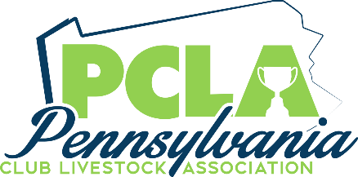

Pennsylvania Club Livestock Association
Evan Vonada Memorial Grant
Lucas Hayman Memorial Grant

$1,000 Scholarship
Deadline for all applications June 1, 2022
Winner will be announced at the PCLA Annual Banquet August 6, 2022
Please contact Jason McGinnis at 724-787-5572 or Jason.mcginnis@resfuel.com with any questions
Qualifications
- You must currently be attending college or a trade school.
- Must be a current or former PCLA member
Applicant Information
Full Name
Home Address
City | State |  | Zip
Email
Home Phone: |  | Cell Phone:
Birth Date
Name(s) of Parent/Guardian
- Under the age 23 as of January 1, 2022
College Information
School Name
School Address
City | State | Zip
Major:
Degree you will receive:
GPA | Anticipated Graduation Date

Pennsylvania Club Livestock Association
Evan Vonada Memorial Grant
Lucas Hayman Memorial Grant

Name _________________________________________________________
Academic Achievements
1
2
3
4
5
6
Community Service
1
2
3
4
5
6
Livestock Awards/Accomplishments
1
2
3
4
5
6

Scholarship Requirement
1. Complete entire application (attach additional pages if required)
2. Include one (1) page essay explaining how showing livestock has impacted your life.
3, Attach a copy of your Spring 2022 semester schedule or transcript

Send completed application with all required documents to the address below.
Must be postmarked by June 1, 2022.
PCLA Evan Vonada Memorial Scholarship
c/o Jason McGinnis
3775 Rayne Church Road
Indiana, PA 15701

